NEPAL COLLEGE OF INFORMATION TECHNOLOGY
Balkumari, Lalitpur
Affiliated to Pokhara University

LAB REPORT FOR SIMULATION AND MODELING


LAB REPORT 1: VERIFICATION OF OHM’S LAW

Submitted by: Submitted to:
Name: Arpan Adhikari Resha Deo
Roll No.: 231309
BECE (6th SEM)

THEORY:

Ohm's Law is one of the fundamental principles of electrical engineering and physics. It was proposed by Georg Simon Ohm in 1827. The law states that the current flowing through a conductor is directly proportional to the voltage applied across it, provided that the temperature and other physical conditions remain constant.
The mathematical relationship is:
V = I × R
Rearranging the equation:
I = V / R
R = V / I
Where:
- V = Voltage (Volts, V)
- I = Current (Amperes, A)
- R = Resistance (Ohms, Ω)

Graphical Interpretation
According to Ohm's Law, for a conductor with constant resistance, voltage and current are directly proportional. When Voltage (V) is plotted on the X-axis and Current (I) on the Y-axis, the resulting graph is a straight line passing through the origin.
The slope of the graph is:
Slope = ΔI / ΔV = 1 / R
The graph provides useful information about the resistance of the conductor:
- Higher resistance → Smaller slope (less steep line)
- Lower resistance → Larger slope (steeper line)
- A straight-line graph passing through the origin indicates that the conductor obeys Ohm's Law

Simulation Using C File Handling
In this experiment, a software-based simulation is used instead of a physical circuit. A C program is developed to calculate current values for different voltages using Ohm's Law and store the results in a CSV file.
The simulation performs the following tasks:
- Varies the voltage from 0 V to 20 V in steps of 1 V.
- Calculates the corresponding current using:
I = V / R
- Stores the voltage and current values in a CSV file.
- Uses C file handling functions to create and manage the output file.

Function | Purpose
fopen() | Opens a file for reading or writing
fprintf() | Writes formatted data to a file
fclose() | Closes the file and saves all data
C-PROGRAM:

#include <stdio.h>
#include <stdlib.h>

#define RESISTANCE 100.0
#define VOLTAGE_MIN 0.0
#define VOLTAGE_MAX 20.0
#define VOLTAGE_STEP 1.0
#define OUTPUT_FILE "ohms_law.csv"

int main()
{
FILE *fp;
double voltage, current;
fp = fopen(OUTPUT_FILE, "w");
if (fp == NULL)
{
printf("Error opening file!\n");
return 1;
}
fprintf(fp, "Voltage (V),Current (A),Resistance (Ohm)\n");
for (voltage = VOLTAGE_MIN;
voltage <= VOLTAGE_MAX;
voltage += VOLTAGE_STEP)
{
current = voltage / RESISTANCE;
fprintf(fp, "%.2f,%.4f,%.2f\n",
voltage, current, RESISTANCE);
}
fclose(fp);
printf("Data written to %s\n", OUTPUT_FILE);
return 0;
}

OBSERVATIONS AND DATA TABLE:

The following table shows the simulated data generated by the C program for a fixed resistance of 100 Ω:

Voltage (V) | Current (A) | Resistance (Ω)
0.00 | 0.0000 | 100.00
1.00 | 0.0100 | 100.00
2.00 | 0.0200 | 100.00
3.00 | 0.0300 | 100.00
4.00 | 0.0400 | 100.00
5.00 | 0.0500 | 100.00
10.00 | 0.1000 | 100.00
15.00 | 0.1500 | 100.00
20.00 | 0.2000 | 100.00

The graph below shows the V-I characteristic curve generated from the simulated data. The straight line through the origin confirms Ohm's Law.

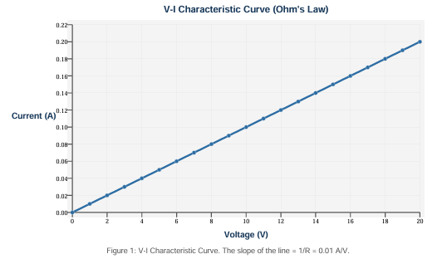
RESULT:
The simulation verified Ohm’s Law successfully. The current increased linearly with voltage, confirming a direct proportional relationship. The V–I graph obtained was a straight line passing through the origin. The calculated slope matched the theoretical value:
Slope = 1 / R = 1 / 100 = 0.01 A/V
The CSV file successfully stored all generated voltage and current values for analysis.

CONCLUSION:
This experiment demonstrated the verification of Ohm’s Law using a C programming simulation and file handling. The results showed that current is directly proportional to voltage and the V–I graph forms a straight line through the origin. The theoretical slope value was validated, confirming the accuracy of the simulation.
Hence, Ohm’s Law was successfully verified using C programming.

